Scooped by Jonathan Plett

28.7.2017

[**Effects of discrete bioactive microbial volatiles on plants and fungi**](http://onlinelibrary.wiley.com/doi/10.1111/pce.13011/full)

[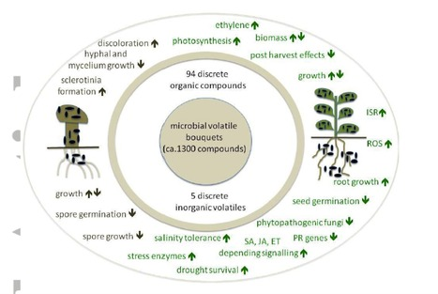](http://onlinelibrary.wiley.com/doi/10.1111/pce.13011/full)

From [onlinelibrary.wiley.com](http://onlinelibrary.wiley.com/doi/10.1111/pce.13011/full) - [June 30, 8:38 AM](http://www.scoop.it/t/plant-microbe-interactions-14/p/4080942353/2017/06/30/effects-of-discrete-bioactive-microbial-volatiles-on-plants-and-fungi)

Plants live in association with microorganisms, which are well known as a rich source of specialized metabolites, including volatile compounds. The increasing numbers of described plant microbiomes allowed manifold phylogenetic tree deductions, but less emphasis is presently put on the metabolic capacities of plant-associated microorganisms. With the focus on small volatile metabolites we summarize i) the knowledge of prominent bacteria of plant microbiomes, ii) present the state-of-the-art of individual (discrete) microbial organic and inorganic volatiles affecting plants and fungi, and iii) emphasize the high potential of microbial volatiles in mediating microbe-plant interactions. So far, 94 discrete organic and five inorganic compounds were investigated, most of them trigger alterations of the growth, physiology and defense responses in plants and fungi but little is known about the specific molecular and cellular targets. Large overlaps in emission profiles of the emitters and receivers render specific VOC-mediated interactions highly unlikely for most bioactive mVOCs identified so far.

**[Share](https://www.facebook.com/sharer/sharer.php?app_id=165307520164712&kid_directed_site=0&sdk=joey&u=http%3A%2F%2Fwww.scoop.it%2Ft%2Fplant-microbe-interactions-14%2Fp%2F4080942353%2F2017%2F06%2F30%2Feffects-of-discrete-bioactive-microbial-volatiles-on-plants-and-fungi&display=popup&ref=plugin&src=share_button)**[70](https://www.facebook.com/sharer/sharer.php?app_id=165307520164712&kid_directed_site=0&sdk=joey&u=http%3A%2F%2Fwww.scoop.it%2Ft%2Fplant-microbe-interactions-14%2Fp%2F4080942353%2F2017%2F06%2F30%2Feffects-of-discrete-bioactive-microbial-volatiles-on-plants-and-fungi&display=popup&ref=plugin&src=share_button)

[Tweet](https://twitter.com/intent/tweet?original_referer=http%3A%2F%2Fwww.scoop.it%2Ft%2Fplant-microbe-interactions-14%2Fp%2F4080942353%2F2017%2F06%2F30%2Feffects-of-discrete-bioactive-microbial-volatiles-on-plants-and-fungi&ref_src=twsrc%5Etfw&text=Effects%20of%20discrete%20bioactive%20microbial%20volatiles%20on%20plants%20and%20fungi&tw_p=tweetbutton&url=http%3A%2F%2Fsco.lt%2F6Cvxir&via=scoopit)