Organic hedgehogs | DOI: 10.1002/anie.200((will be filled in by the editorial staff))
Octamethylbicyclo[3.2.1]octadienes from Serratia odorifera**
Stephan H. von Reuß, Marco Kai, Birgit Piechulla, Wittko Francke*
Dedicated to Professor Dr. H. M. R. Hoffmann on the occassion of his 75th birthday.

Plant root associated rhizobacteria have recently attracted attention due to the emission of volatile organic compounds capable of affecting growth and development of plants, fungi and other bacteria through largely unknown mechanisms.^{[1]} Rhizobacterial volatiles released by Serratia odorifera 4Rx13 have been reported to inhibit growth of Arabidopsis thaliana,^{[2]} as well as mycelial growth of fungal plant pathogens like Rhizoctonia solani.^{[2,3]}
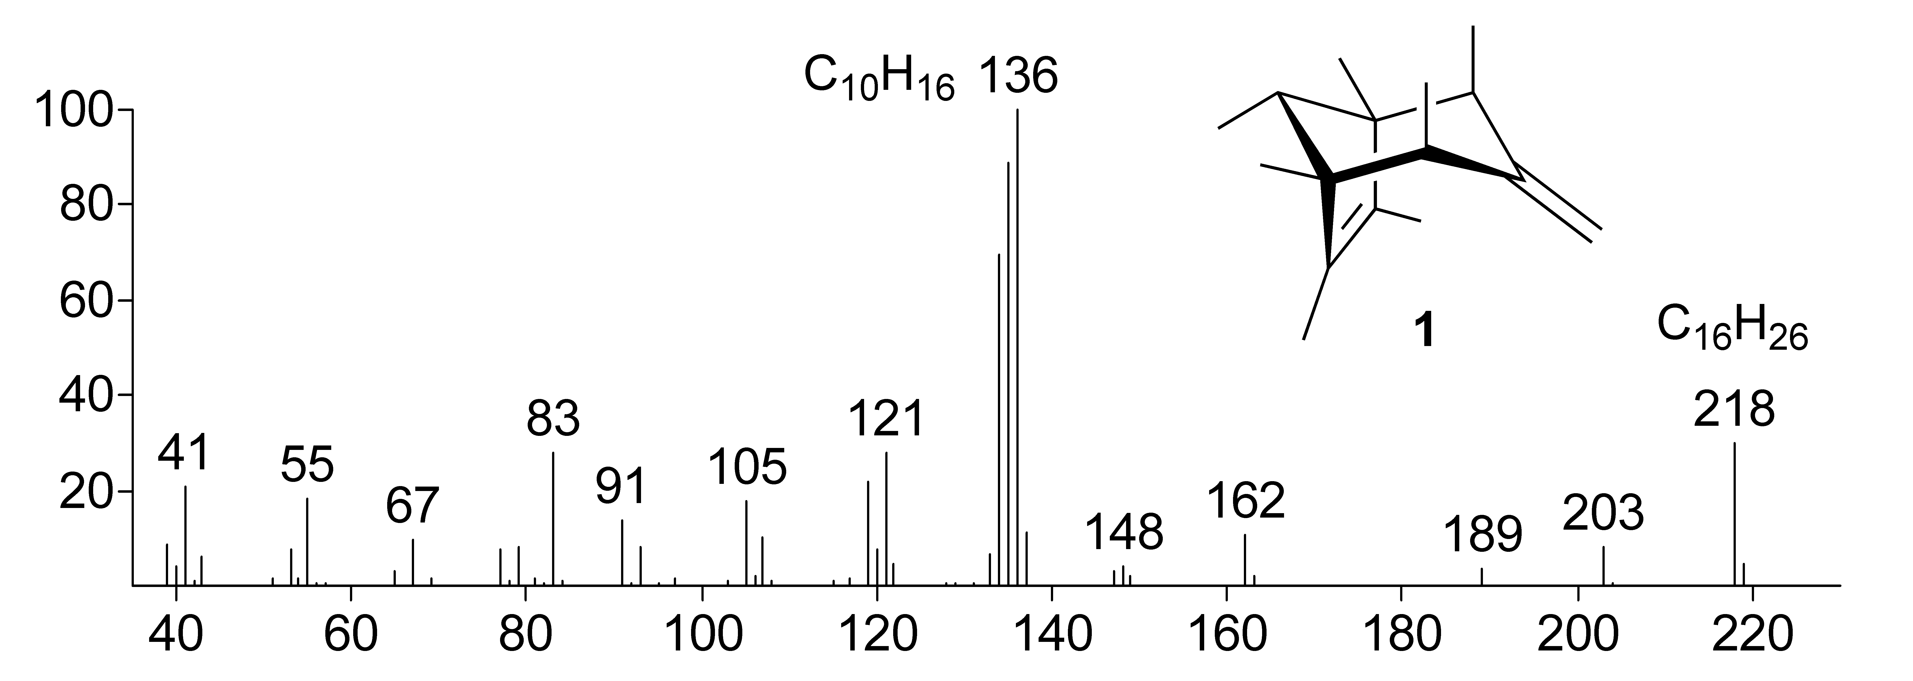
Figure 1. 70 eV mass spectrum of sodorifen (1) from S. odorifera.
Volatiles released by S. odorifera are highly dominated by a single compound (1). Its 70 eV EI mass spectrum (Figure 1) exhibits a signal for the molecular ion at m/z 218 [M⁺] and an unusual set of highly abundant fragments at m/z 136 (100), 135 (89), and 134 (70). Coupled GC/HR-MS assigned the molecular formula to be C₁₆H₂₆ revealing four units of unsaturation. Using SuperQ as an adsorbens, about 1 mg of 1 was obtained from head space collections of volatiles released by a 10 liter culture of S. odorifera and elution with dichloromethane.^{[4]} The ¹H NMR spectrum in C₆D₆ exhibited signals for one exocyclic methylene group at 4.63 (s, 2H) and one secondary methyl group at 0.73 (d, J = 6.9 Hz, 3H) connected to a methine group at 2.04 (q, J = 6.9 Hz, 1H). Furthermore, isochoric signals corresponding to two secondary methyl groups at 1.12 (d, J = 7.3 Hz, 6H), each one connected to its own methine group at 2.08 (q, J = 7.2 Hz, 2H) were identified, along with two quaternary methyl groups at 0.83 (s, 6H), and two olefinic methyl groups at 1.41 (s, 6H). The ¹H NMR integral ratio of 1:2:3:6 along with the large number of isochoric methyl signals indicated a poly-methylated compound showing C_{s} symmetry. Inspection of the ¹³C PENDANT and HMQC spectra confirmed the presence of one exocyclic methylene group at 111.1 (t) and 156.0 (s), two different types of methine groups at 39.9 and 44.1, as well as four types of methyl groups at 9.6, 11.0, 17.7, and 19.5 ppm. The remaining 4 quaternary carbons, required for the molecular composition of C₁₆H₂₆, were observed at 51.5 and 134.2 in agreement with isochoric pairs of quaternary and olefinic carbons, respectively. Inspection of the COSY-90 spectrum confirmed the identification of five distinguishable partial structures, which could be connected according to the long range H,C-correlations from the HMBC spectrum, thus, completing the structure of the novel 1,2,4,5,6,7,8-heptamethyl-3-methylenebicyclo[3.2.1]oct-6-ene (1) to which we assign the trivial name sodorifen. The stereochemistry of sodorifen was deduced from the gp-NOESY spectrum. NOE interactions between the equivalent secondary methyl groups (2- and 4-CH₃) and the 8-CH methine proton indicated an 8-anti-2,4-bisaxial configuration.
[∗] Prof. Dr. Dr. h.c. mult. W. Francke, S. H. von Reuß
Department für Organische Chemie
Universität Hamburg
Martin-Luther-King-Platz 6, 20146 Hamburg (Germany)
Fax: (+49) 40-42838-3834
E-mail: francke@chemie.uni-hamburg.de
Prof. Dr. B. Piechulla, M. Kai
Institut für Biowissenschaften
Universität Rostock
Albert-Einstein-Straße 3, 18059 Rostock (Germany)
[∗∗] This work was financially supported by the Deutsche Forschungsgemeinschaft (Fr-507/16-1 and PI-153/26-1). We like to thank Dr. V. Sinwell and Dr. S. Franke (Hamburg) for NMR and HR-MS measurements.
Supporting information for this article is available on the WWW under http://www.angewandte.org or from the author.
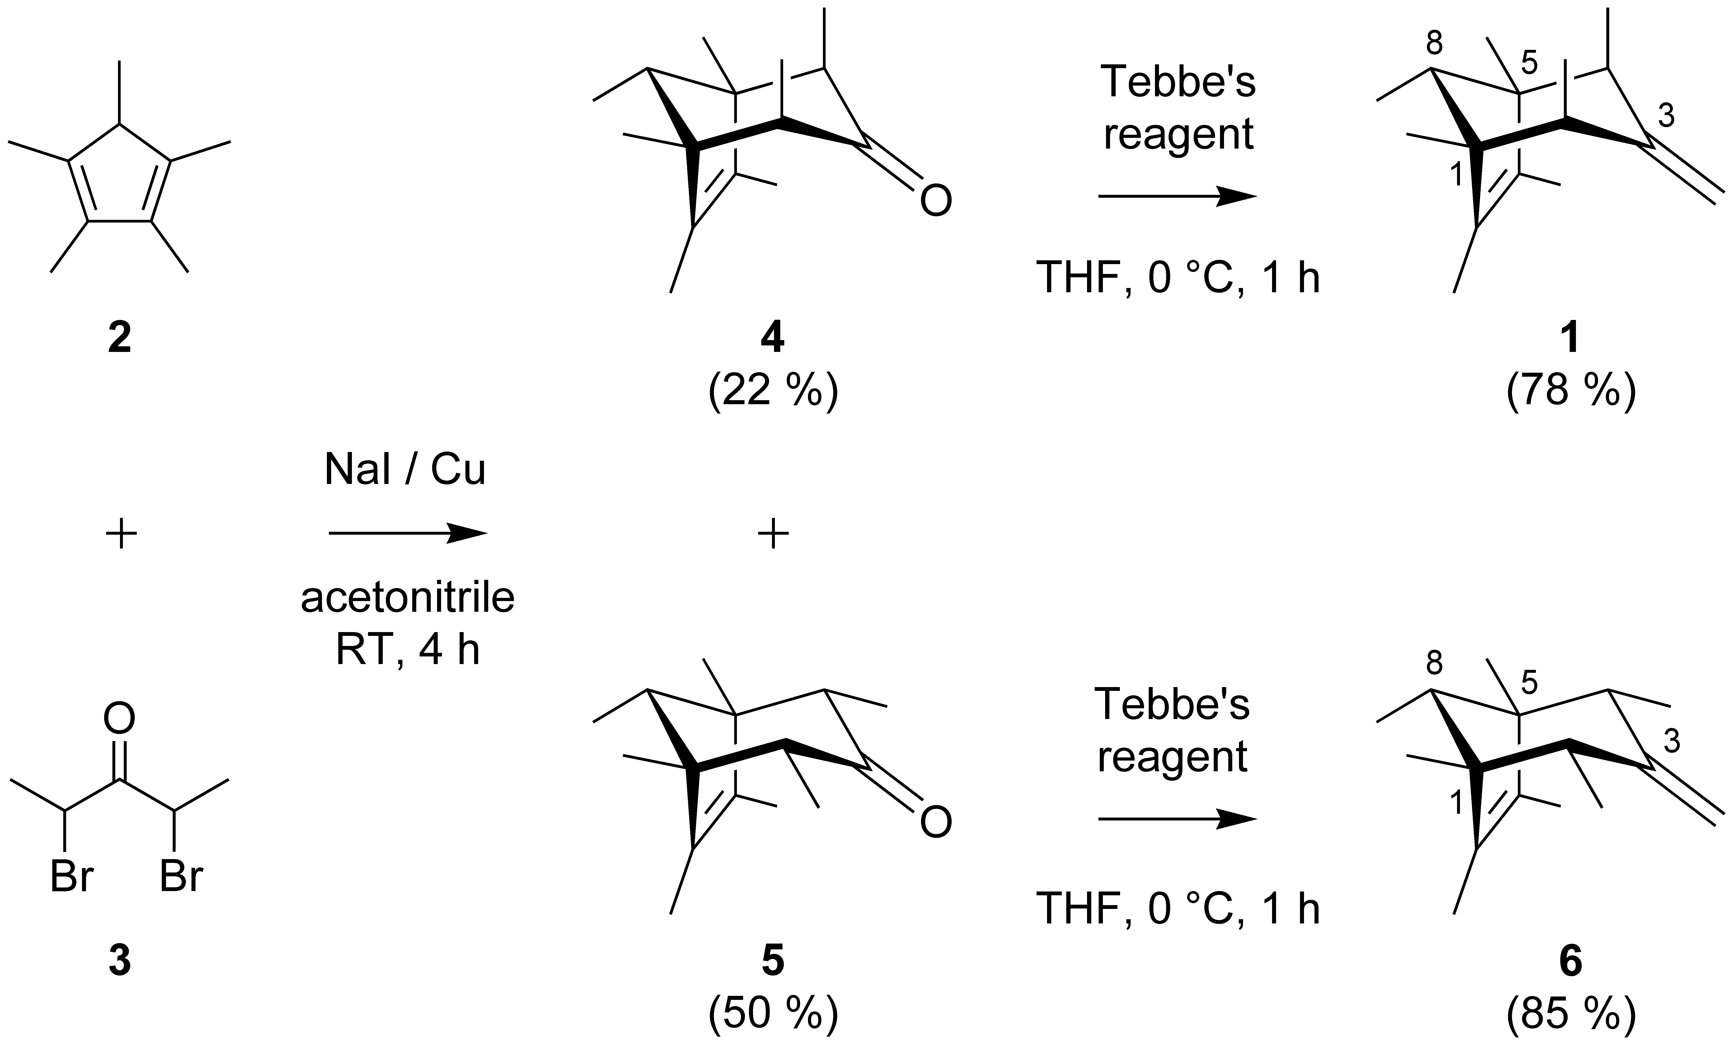
Scheme 1. Synthesis of 1,2,4,5,6,7,8-heptamethyl-3-methylenebicyclo- [3.2.1]oct-6-enes 1 and 6.
The structure of sodorifen 1 was unambiguously proven by synthesis (Scheme 1).^{[4]} Access to the bicyclo[3.2.1]octadiene skeleton via 6π,7C-cycloaddition has been described by H. M. R. Hoffmann.^{[5]} Reaction of commercially available pentamethylcyclo-pentadiene 2 with 2,4-dibromopentan-3-one 3 using Hoffmann’s sodium iodide / copper route^{[6]} afforded 1 : 2 – 4 mixtures of 8-anti-configured 2,4-bisaxial- (exo) and 2,4-bisequatorial- (endo) 1,2,4,5,6,7,8-heptamethylbicyclo[3.2.1]oct-6-en-3-ones 4 and 5, respectively. Trace amounts of the corresponding syn-configured C-8-epimers were also detected upon GC/EI-MS (< 0.5 %). Care had to be taken to prevent epimerisation of 4 under acidic or alkaline conditions or upon distillation resulting in the formation of 5 via the unstable mixed axial-equatorial configured (chiral) isomer. The separation of the isomers 4 and 5 was achieved by crystallization at –20 °C followed by column chromatography. Wittig reaction of triphenylmethylenephosphorane and 4 led to epimerisation, whereas 5 did not react at all. In contrast, reaction with Tebbe’s reagent^{[7]} afforded the corresponding hydrocarbons 1 and 6 in up to 80 % total yield. The isomeric hydrocarbons 1 and 6 were isolated by a sequence of column chromatography and preparative gas chromatography. Only 8-anti-2,4-bisaxial-1,2,4,5,6,7,8-heptamethyl-3-methylenebicyclo-[3.2.1]oct-6-ene (sodorifen) 1 exhibited identical mass spectra and GC retention indices as well as ¹H and ¹³C NMR spectra as the natural product. The stereoisomer 6, as well as the corresponding 8-syn-epimers were not detected in the headspace of S. odorifera.
S. odorifera releases a bouquet of new hydrocarbons, among which the major component, sodorifen (1), dominates by 85 %. It is accompanied by a multitude of minor and trace amounts of isomers, some of which were also detected upon treatment of 1 with acidic Amberlyst® 15-resin. To the best of our knowledge, the structures of these volatiles are unique among natural products, showing one extra-skeletal carbon attached to each of those of the core system. First ¹³C-labelling experiments with [2-¹³C]-acetate targeting a polyketide or MVA biogenesis resulted in a slight enrichment of [¹³C]-sodorifen, however, the distribution of the label(s) did not provide conclusive results. Investigations concerning the biological significance of the S. odorifera bouquet in general and specifically that of sodorifen are presently carried out.
Experimental Section
Experimental Details are provided in the supporting information
Received: ((will be filled in by the editorial staff))
Published online on ((will be filled in by the editorial staff))
Keywords: Bicyclic Hydrocarbons · Natural Products · Rhizobacteria · Serratia odorifera · Synthesis
[1] M. Kai, M. Haustein, F. Molina, A. Petri, B. Scholz, B. Piechulla, Appl. Microbiol. Biotechnol. 2009, 81, 1001-1012.
[2] A. Vespermann, M. Kai, B. Piechulla, Appl. Environ. Microbiol. 2007, 73, 5639-5641.
[3] M. Kai, U. Effmert, G. Berg, B. Piechulla, Arch. Microbiol. 2007, 187, 351-360.
[4] Experimental details are provided in the supporting information.
[5] a) H. M. R. Hoffmann, Angew. Chem. 1973, 85, 877-894; Angew. Chem. Int. Ed. Engl. 1973, 12, 819-835; b) H. M. R. Hoffmann, Angew. Chem. 1984, 96, 29-48; Angew. Chem. Int. Ed. Engl. 1984, 23, 1-19.
[6] M. R. Ashcroft, H. M. R. Hoffmann, Org. Synth. 1978, 58, 17-24.
[7] F. N. Tebbe, G. W. Parshall, G. S. Reddy, J. Am. Chem. Soc. 1978, 100, 3611-3613.

Entry for the Table of Contents (Please choose one layout)

Layout 1:
Organic hedgehogs | 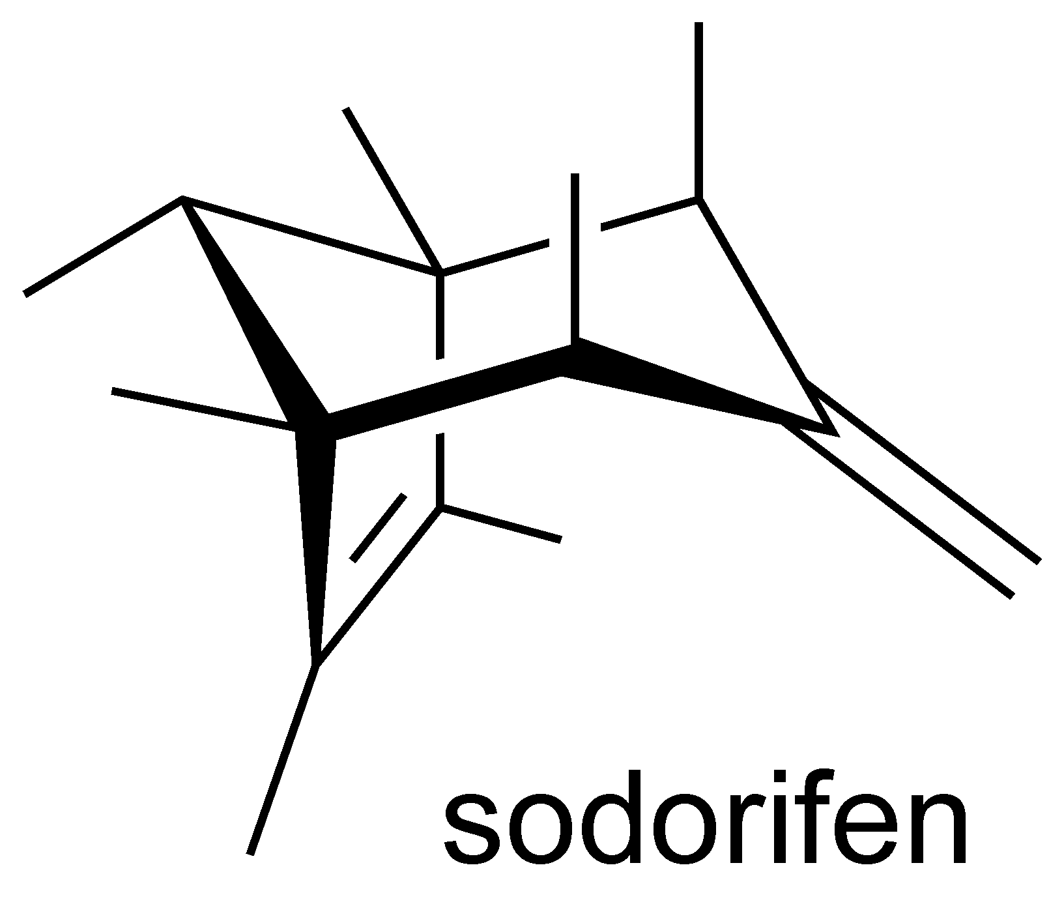 | Sodorifen, a C₁₆ hydrocarbon with an unprecedented carbon skeleton, is the major volatile component released by the rhizobacterium Serratia odorifera. Its structure reveals the humorous side of evolution.
Stephan H. von Reuß, Marco Kai, Birgit Piechulla, Wittko Francke* __________ Page – Page
Octamethylbicyclo[3.2.1]octadienes from Serratia odorifera

